Practical 1

**Aim:**

Create your resume using HTML tags. Experiment with colors, text, link, and also other tags you studied.

**Code:**

**Index.html**

<!DOCTYPE html>

<html lang="en">

  <head>

    <meta charset="UTF-8" />

    <meta http-equiv="X-UA-Compatible" content="IE=edge" />

    <meta name="viewport" content="width=device-width, initial-scale=1.0" />

    <link

      href="https://fonts.googleapis.com/css?family=Lato:400,300,700"

      rel="stylesheet"

      type="text/css"

    />

    <link rel="stylesheet" href="css/style.css" />

    <title>Ankit Verma | Web Dev - Resume</title>

  </head>

  <body>

    <div class="container">

      <div class="header">

        <div class="full-name">

          <span class="first-name">Ankit</span>

          <span class="last-name">Verma</span>

        </div>

        <div class="contact-info">

          <span class="email">Email: </span>

          <span class="email-val">ankitverma209171@gmail.com</span>

          <span class="separator"></span>

          <span class="phone">Phone: </span>

          <span class="phone-val">932-711-4805</span>

        </div>

        <div class="about">

          <span class="position">Full-Stack Developer </span>

          <span class="desc">

            I am a full-stack developer with more than 1 years of experience

            writing html, css, and js for front-end and django as back-end. I'm

            motivated, result-focused and seeking a successful team-oriented

            company with opportunity to grow.

          </span>

        </div>

      </div>

      <div class="details">

        <div class="section">

          <div class="section__title">Experience</div>

          <div class="section__list">

            <div class="section__list-item">

              <div class="left">

                <div class="name">Freelancer</div>

                <div class="addr">Upwork</div>

                <div class="duration">July 2021 - Current</div>

              </div>

              <div class="right">

                <div class="name">Web Dev</div>

                <div class="desc">

                  Build Web Solutions with latest technologies in industry

                </div>

              </div>

            </div>

            <div class="section__list-item">

              <div class="left">

                <div class="name">Vision Web Solutions</div>

                <div class="addr">Ahmedabad, Gujarat, India</div>

                <div class="duration">Dec 2020 - Feb 2021</div>

              </div>

              <div class="right">

                <div class="name">Web Dev Intern</div>

                <div class="desc">

                  Build support APIs for BuuyIt (E-commerce solution)

                </div>

              </div>

            </div>

          </div>

        </div>

        <div class="section">

          <div class="section__title">Education</div>

          <div class="section__list">

            <div class="section__list-item">

              <div class="left">

                <div class="name">VGEC</div>

                <div class="addr">Ahmedabad, Gujarat, India</div>

                <div class="duration">Aug 2019 - Current</div>

              </div>

              <div class="right">

                <div class="name">Information Technology</div>

                <div class="desc">Bachelor of Engineering (CGPA - 8.75)</div>

              </div>

            </div>

            <div class="section__list-item">

              <div class="left">

                <div class="name">GSFC School</div>

                <div class="addr">Vadodara, Gujarat, India</div>

                <div class="duration">Jun 2017 - Mar 2019</div>

              </div>

              <div class="right">

                <div class="name">Science Stream</div>

                <div class="desc">GHSEB (89%)</div>

              </div>

            </div>

          </div>

        </div>

        <div class="section">

          <div class="section__title">Projects</div>

          <div class="section__list">

            <div class="section__list-item">

              <div class="name">Exam Shield</div>

              <div class="text">

                Exam Shield is an fool-proof examination system developed with

                rich features to conduct fair examinations and evaluations of

                the students online. <b>Technologies:</b> Django | CSS |

                Javascript

              </div>

            </div>

            <div class="section__list-item">

              <div class="name">Radhe Caterering Website</div>

              <div class="text">

                Radhe Caterering Website is a static website developed for

                creating business online presence and attract new customers

                online. <b>Technologies:</b> Django | CSS | Javascript

              </div>

            </div>

          </div>

        </div>

        <div class="section">

          <div class="section__title">Skills</div>

          <div class="skills">

            <div class="skills__item">

              <div class="left"><div class="name">Javascript</div></div>

              <div class="right">

                <input id="ck1" type="checkbox" checked />

                <label for="ck1"></label>

                <input id="ck2" type="checkbox" checked />

                <label for="ck2"></label>

                <input id="ck3" type="checkbox" checked />

                <label for="ck3"></label>

                <input id="ck4" type="checkbox" />

                <label for="ck4"></label>

                <input id="ck5" type="checkbox" />

                <label for="ck5"></label>

              </div>

            </div>

          </div>

          <div class="skills__item">

            <div class="left"><div class="name">CSS</div></div>

            <div class="right">

              <input id="ck1" type="checkbox" checked />

              <label for="ck1"></label>

              <input id="ck2" type="checkbox" checked />

              <label for="ck2"></label>

              <input id="ck3" type="checkbox" checked />

              <label for="ck3"></label>

              <input id="ck4" type="checkbox" checked />

              <label for="ck4"></label>

              <input id="ck5" type="checkbox" />

              <label for="ck5"></label>

            </div>

          </div>

          <div class="skills__item">

            <div class="left"><div class="name">Django</div></div>

            <div class="right">

              <input id="ck1" type="checkbox" checked />

              <label for="ck1"></label>

              <input id="ck2" type="checkbox" checked />

              <label for="ck2"></label>

              <input id="ck3" type="checkbox" checked />

              <label for="ck3"></label>

              <input id="ck4" type="checkbox" checked />

              <label for="ck4"></label>

              <input id="ck5" type="checkbox" checked />

              <label for="ck5"></label>

            </div>

          </div>

        </div>

        <div class="section">

          <div class="section__title">Interests</div>

          <div class="section__list">

            <div class="section__list-item">Reading, drawing, programming.</div>

          </div>

        </div>

      </div>

    </div>

  </body>

</html>

**Style.css**

* {

  margin: 0;

  padding: 0;

  box-sizing: border-box;

}

html {

  height: 100%;

}

body {

  min-height: 100%;

  background: #eee;

  font-family: "Lato", sans-serif;

  font-weight: 400;

  color: #222;

  font-size: 14px;

  line-height: 26px;

  padding-bottom: 50px;

}

.container {

  max-width: 700px;

  background: #fff;

  margin: 0px auto 0px;

  box-shadow: 1px 1px 2px #dad7d7;

  border-radius: 3px;

  padding: 40px;

  margin-top: 50px;

}

.header {

  margin-bottom: 30px;

}

.header .full-name {

  font-size: 40px;

  text-transform: uppercase;

  margin-bottom: 5px;

}

.header .first-name {

  font-weight: 700;

}

.header .last-name {

  font-weight: 300;

}

.header .contact-info {

  margin-bottom: 20px;

}

.header .email,

.header .phone {

  color: #999;

  font-weight: 300;

}

.header .separator {

  height: 10px;

  display: inline-block;

  border-left: 2px solid #999;

  margin: 0px 10px;

}

.header .position {

  font-weight: bold;

  display: inline-block;

  margin-right: 10px;

  text-decoration: underline;

}

.details {

  line-height: 20px;

}

.details .section {

  margin-bottom: 40px;

}

.details .section:last-of-type {

  margin-bottom: 0px;

}

.details .section__title {

  letter-spacing: 2px;

  color: #54afe4;

  font-weight: bold;

  margin-bottom: 10px;

  text-transform: uppercase;

}

.details .section__list-item {

  margin-bottom: 40px;

}

.details .section__list-item:last-of-type {

  margin-bottom: 0;

}

.details .left,

.details .right {

  vertical-align: top;

  display: inline-block;

}

.details .left {

  width: 60%;

}

.details .right {

  text-align: right;

  width: 39%;

}

.details .name {

  font-weight: bold;

}

.details a {

  text-decoration: none;

  color: #000;

  font-style: italic;

}

.details a:hover {

  text-decoration: underline;

  color: #000;

}

.details .skills__item {

  margin-bottom: 10px;

}

.details .skills__item .right input {

  display: none;

}

.details .skills__item .right label {

  display: inline-block;

  width: 20px;

  height: 20px;

  background: #c3def3;

  border-radius: 20px;

  margin-right: 3px;

}

.details .skills__item .right input:checked + label {

  background: #79a9ce;

}

**Screenshot:**

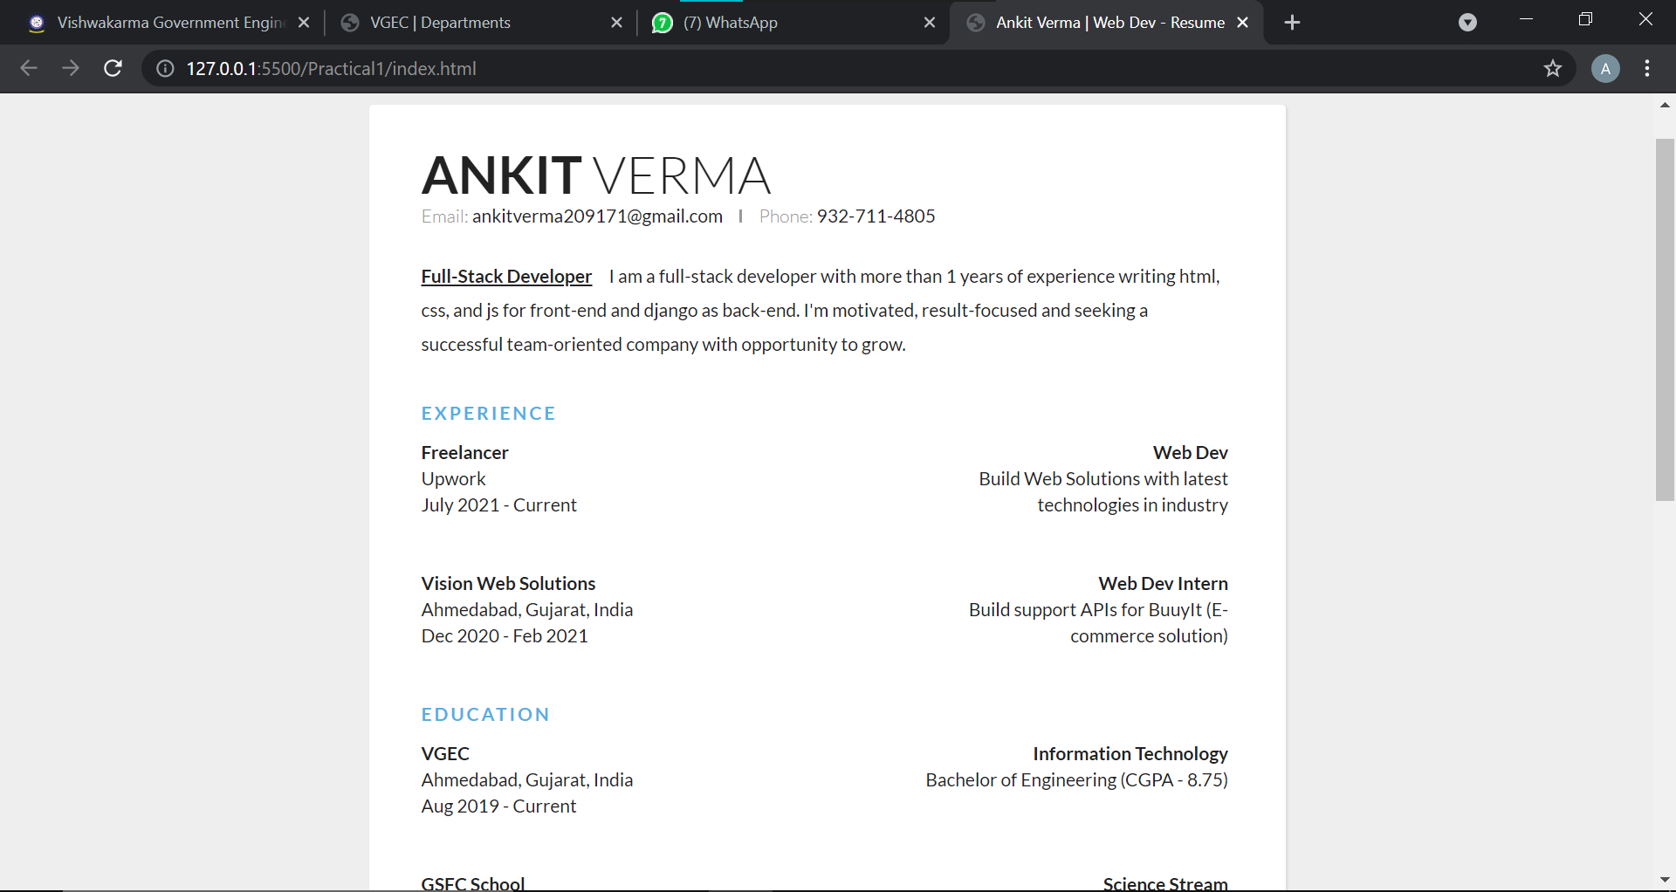

Practical 2

**Aim:**

Design static web pages for your college containing a description of the courses, departments, faculties, library etc. Provide links for navigation among pages.

**Code:**

**Index.html**

<!DOCTYPE html>

<html lang="en">

  <head>

    <meta charset="UTF-8" />

    <meta http-equiv="X-UA-Compatible" content="IE=edge" />

    <meta name="viewport" content="width=device-width, initial-scale=1.0" />

    <link rel="stylesheet" href="css/style.css" />

    <title>VGEC | Home</title>

  </head>

  <body>

    <nav>

      <ul>

        <li>

          <a href="index.html"><img src="img/logo.png" alt="logo image" /></a>

        </li>

        <li>

          <a href="index.html">VGEC</a>

        </li>

        <li><a href="index.html" class="active">Home</a></li>

        <li><a href="courses.html">Courses</a></li>

        <li><a href="faculties.html">Faculties</a></li>

        <li><a href="library.html">Library</a></li>

      </ul>

    </nav>

    <div class="card">

      <div class="container">

        <img src="img/hero.jpg" alt="Expert Lecture" width="100%" />

        <p>

          Vishwakarma Government Engineering College, Ahmedabad was established

          in August 1994, with an objective of imparting higher education in

          various fields of engineering and technology. This institute is

          recognized by All India Council of Technical Education (AICTE), New

          Delhi and Institute of Engineers (India). The college is administrated

          by Directorate of Technical Education, Gujarat State, Gandhinagar and

          is affiliated with Gujarat Technological University. VGEC shifted to

          its own campus at Chandkheda, Ahmedabad in the year 2004.

        </p>

        <br />

        <h3><b>VISION</b></h3>

        <p>

          To create an ecosystem for proliferation of socially responsible and

          technically sound engineers, innovators and entrepreneurs.

        </p>

        <br />

        <h3><b>MISSION</b></h3>

        <p>

          To develop state-of-the-art laboratories and well-equipped academic

          infrastructure.

        </p>

        <p>

          To motivate faculty and staff for qualification up-gradation, and

          enhancement of subject knowledge.

        </p>

        <p>

          To promote research, innovation and real life problem solving skills.

        </p>

        <p>

          To strengthen linkages with industries, academic and research

          organizations.

        </p>

        <p>

          To reinforce concern for sustainability, natural resource conservation

          and social responsibility.

        </p>

      </div>

    </div>

    <footer class="footer">

      <p>VGEC &copy;2021</p>

    </footer>

  </body>

</html>

**Courses.html**

<!DOCTYPE html>

<html lang="en">

  <head>

    <meta charset="UTF-8" />

    <meta http-equiv="X-UA-Compatible" content="IE=edge" />

    <meta name="viewport" content="width=device-width, initial-scale=1.0" />

    <link rel="stylesheet" href="css/style.css" />

    <title>VGEC | Courses</title>

  </head>

  <body>

    <nav>

      <ul>

        <li>

          <a href="index.html"><img src="img/logo.png" alt="logo image" /></a>

        </li>

        <li>

          <a href="index.html">VGEC</a>

        </li>

        <li><a href="index.html">Home</a></li>

        <li><a href="courses.html" class="active">Courses</a></li>

        <li><a href="faculties.html">Faculties</a></li>

        <li><a href="library.html">Library</a></li>

      </ul>

    </nav>

    <div class="card">

      <div class="container">

        <p>

          The institute runs 9 Under Graduate (UG) engineering programs and 2

          Post Graduate (PG) engineering programs. Out of 9 UG programs, four

          programs are accredited by the NBA

        </p>

        <br />

        <h3><b>Under Graduate Programs</b></h3>

        <p>

          Admission process to all UG programs is carried out by the state level

          Admission Committee for Professional Courses (ACPC). For more details,

          visit ACPC website

          <a href="www.jacpcldce.ac.in/be.asp">www.jacpcldce.ac.in/be.asp</a>

        </p>

        <p>Fees: Tuition Fee for Boys: Rs. 1500/-</p>

        <p>Fees: Tuition Fee for Girls: NIL</p>

        <br />

        <table id="ug-intake">

          <thead>

            <tr>

              <th>Sr.No.</th>

              <th>Branch</th>

              <th>Course</th>

              <th>Intake</th>

              <th>Accreditation Status</th>

            </tr>

          </thead>

          <tbody>

            <tr>

              <th>1</th>

              <td>Chemical Engineering</td>

              <td>UG</td>

              <td>60</td>

              <td>Accredited For 3 Years Upto 30/06/2022</td>

            </tr>

            <tr>

              <th>2</th>

              <td>Computer Engineering</td>

              <td>UG</td>

              <td>120</td>

              <td></td>

            </tr>

            <tr>

              <th>3</th>

              <td>Civil Engineering</td>

              <td>UG</td>

              <td>60</td>

              <td>Accredited For 3 Years Upto 30/06/2022</td>

            </tr>

            <tr>

              <th>4</th>

              <td>Electrical Engineering</td>

              <td>UG</td>

              <td>120</td>

              <td></td>

            </tr>

            <tr>

              <th>5</th>

              <td>Electronics &amp; Communication Engineering</td>

              <td>UG</td>

              <td>120</td>

              <td></td>

            </tr>

            <tr>

              <th>6</th>

              <td>Information Technology</td>

              <td>UG</td>

              <td>60</td>

              <td>Accredited For 3 Years Upto 30/06/2022</td>

            </tr>

            <tr>

              <th>7</th>

              <td>Instrumentation &amp; Control Engineering</td>

              <td>UG</td>

              <td>60</td>

              <td></td>

            </tr>

            <tr>

              <th>8</th>

              <td>Mechanical Engineering</td>

              <td>UG</td>

              <td>60</td>

              <td>Accredited For 3 Years Upto 30/06/2022</td>

            </tr>

            <tr>

              <th>9</th>

              <td>Power Electronics Engineering</td>

              <td>UG</td>

              <td>60</td>

              <td></td>

            </tr>

          </tbody>

        </table>

        <br />

        <h3><b>Post Graduate Programs</b></h3>

        <p>

          Admission process to all PG programs is carried out by the state level

          Admission Committee for Professional Courses (ACPC) based on valid

          GATE score/Post Graduate Common Entrance Test (PGCET). For more

          details, visit ACPC website

          <a href="www.jacpcldce.ac.in/be.asp">www.jacpcldce.ac.in/be.asp</a>

        </p>

        <br />

        <table id="pg-intake">

          <thead>

            <tr>

              <th>Sr.No.</th>

              <th>Branch</th>

              <th>Course</th>

              <th>Intake</th>

              <th>Accreditation Status</th>

            </tr>

          </thead>

          <tbody>

            <tr>

              <th>1</th>

              <td>Chemical Engineering</td>

              <td>PG</td>

              <td>18</td>

              <td></td>

            </tr>

            <tr>

              <th>2</th>

              <td>Electronics &amp; Communication Engineering</td>

              <td>PG</td>

              <td>18</td>

              <td></td>

            </tr>

          </tbody>

        </table>

      </div>

    </div>

    <footer class="footer">

      <p>VGEC &copy;2021</p>

    </footer>

  </body>

</html>

**Faculties.html**

<!DOCTYPE html>

<html lang="en">

  <head>

    <meta charset="UTF-8" />

    <meta http-equiv="X-UA-Compatible" content="IE=edge" />

    <meta name="viewport" content="width=device-width, initial-scale=1.0" />

    <link rel="stylesheet" href="css/style.css" />

    <title>VGEC | Departments</title>

  </head>

  <body>

    <nav>

      <ul>

        <li>

          <a href="index.html"><img src="img/logo.png" alt="logo image" /></a>

        </li>

        <li>

          <a href="index.html">VGEC</a>

        </li>

        <li><a href="index.html">Home</a></li>

        <li><a href="courses.html">Courses</a></li>

        <li><a href="faculties.html" class="active">Faculties</a></li>

        <li><a href="library.html">Library</a></li>

      </ul>

    </nav>

    <div class="card">

      <div class="container">

        <div class="profile-card">

          <img src="img/profile.jpg" alt="John" style="width: 100%" />

          <h3>Prof. Chirag A. Patel</h3>

          <p class="title">Associate Professor</p>

          <p>Ph.D.</p>

          <p>capatel@vgecg.ac.in</p>

        </div>

        <div class="profile-card">

          <img src="img/profile.jpg" alt="John" style="width: 100%" />

          <h3>Prof. Shailesh J. Molia</h3>

          <p class="title">Associate Professor</p>

          <p>M.E.</p>

          <p>sjmolia@vgecg.ac.in</p>

        </div>

        <div class="profile-card">

          <img src="img/profile.jpg" alt="John" style="width: 100%" />

          <h3>Prof. Nikunj C. Gamit</h3>

          <p class="title">Associate Professor</p>

          <p>M.Tech.</p>

          <p>nikunj.gamit@vgecg.ac.in</p>

        </div>

        <div class="profile-card">

          <img src="img/profile.jpg" alt="John" style="width: 100%" />

          <h3>Prof. Jashvant R. Dave</h3>

          <p class="title">Associate Professor</p>

          <p>M.Tech.</p>

          <p>jrd_it@vgecg.ac.in</p>

        </div>

      </div>

    </div>

    <footer class="footer">

      <p>VGEC &copy;2021</p>

    </footer>

  </body>

</html>

**Library.html**

<!DOCTYPE html>

<html lang="en">

  <head>

    <meta charset="UTF-8" />

    <meta http-equiv="X-UA-Compatible" content="IE=edge" />

    <meta name="viewport" content="width=device-width, initial-scale=1.0" />

    <link rel="stylesheet" href="css/style.css" />

    <title>VGEC | Library</title>

  </head>

  <body>

    <nav>

      <ul>

        <li>

          <a href="index.html"><img src="img/logo.png" alt="logo image" /></a>

        </li>

        <li>

          <a href="index.html">VGEC</a>

        </li>

        <li><a href="index.html">Home</a></li>

        <li><a href="courses.html">Courses</a></li>

        <li><a href="faculties.html">Faculties</a></li>

        <li><a href="library.html" class="active">Library</a></li>

      </ul>

    </nav>

    <div class="card">

      <div class="container">

        <img src="img/library.jpg" alt="Library Image" width="100%" />

        <h3><b>Library Membership</b></h3>

        <p>

          All students and faculty members of Vishwakarma Government Engineering

          College are to be registered as Member of library. Book borrowing

          rights are given to all Students (UG/PG) and faculty members.

        </p>

        <br />

        <h3><b>Location of library</b></h3>

        <p>

          Library is located in Workshop Building, which includes Librarian

          cabin, news paper reading area, book issue and return area, reference

          section, magazine section

        </p>

        <br />

        <h3><b>Library Resources</b></h3>

        <p>

          All books of Library are classified as per Dewey Decimal

          Classification System (DDC). Data entry of all books available in

          library is done in Soul 2.0 Network version. Book issue and return

          facilities, book search option, student membership is to be done

          through this Soul 2.o software.

        </p>

        <br />

        <h3><b>Issue & Return of books Hours</b></h3>

        <p>

          Monday to Friday and working Saturday: 11.00 AM to 2:00PM and 3.00 PM

          to 5.00 PM.

        </p>

        <br />

        <h3><b>Library opening Hours</b></h3>

        <p>Monday to Friday and working Saturday 9:30AM to 6.10PM</p>

        <br />

        <h3><b>Library information</b></h3>

        <br />

        <table class="table stat">

          <tbody>

            <tr>

              <td>Total Area Of The Library</td>

              <td>714 M<sup>2</sup></td>

            </tr>

            <tr>

              <td>Seating Capacity Of The Library</td>

              <td>150</td>

            </tr>

            <tr>

              <td>Working Hours Of Library</td>

              <td>08 Hrs (10.30am To 6.10pm)</td>

            </tr>

            <tr>

              <td>Library Networking Facility</td>

              <td>Yes</td>

            </tr>

            <tr>

              <td>Usage of The Library (No. of Visitors )</td>

              <td>75/Day (Average )</td>

            </tr>

            <tr>

              <td>

                Usage Data Of The Library (In Terms Of Books Issued To The

                Faculty &amp; Students Etc.)

              </td>

              <td>72/Day (Average )</td>

            </tr>

            <tr></tr>

          </tbody>

        </table>

        <h3><b>Branch wise Book Detail</b></h3>

        <br />

        <table class="table stat">

          <thead>

            <tr>

              <th>Course(S) /Department</th>

              <th>Total Vol.</th>

              <th>No. Of Title</th>

            </tr>

          </thead>

          <tbody>

            <tr>

              <td>Electrical Engineering</td>

              <td>5008</td>

              <td>1678</td>

            </tr>

            <tr>

              <td>I.C. Engineering</td>

              <td>2064</td>

              <td>547</td>

            </tr>

            <tr>

              <td>Chemical Engineering</td>

              <td>2425</td>

              <td>981</td>

            </tr>

            <tr>

              <td>IT/CE Engineering</td>

              <td>5483</td>

              <td>1636</td>

            </tr>

            <tr>

              <td>EC Engineering</td>

              <td>4787</td>

              <td>1375</td>

            </tr>

            <tr>

              <td>Power Electronics Engineering</td>

              <td>2556</td>

              <td>568</td>

            </tr>

            <tr>

              <td>Mechanical Engineering</td>

              <td>3839</td>

              <td>728</td>

            </tr>

            <tr>

              <td>Civil / Applied. Mech.</td>

              <td>3350</td>

              <td>860</td>

            </tr>

            <tr>

              <td>General Department</td>

              <td>3602</td>

              <td>756</td>

            </tr>

            <tr>

              <td>Ebooks</td>

              <td></td>

              <td>220</td>

            </tr>

            <tr>

              <td>E-Journals</td>

              <td></td>

              <td>4456</td>

            </tr>

            <tr>

              <td>Journals (Hard Copy) subscribed</td>

              <td></td>

              <td>25</td>

            </tr>

            <tr>

              <td>Total Of Volume &amp; Title</td>

              <td>33500</td>

              <td>9500</td>

            </tr>

          </tbody>

        </table>

      </div>

    </div>

    <footer class="footer">

      <p>VGEC &copy;2021</p>

    </footer>

  </body>

</html>

**Style.css**

* {

  margin: 0;

  padding: 0;

  font-family: Arial, Helvetica, sans-serif;

}

/* brand logo */

nav > ul > li:nth-child(1) > a {

  background-color: #fff;

}

nav > ul > li:nth-child(1) > a > img {

  height: 1rem;

}

/* nav */

nav ul {

  list-style-type: none;

  overflow: hidden;

  background-color: #003975;

}

nav li {

  display: inline;

  float: left;

}

nav li a {

  display: block;

  color: white;

  text-align: center;

  padding: 14px 16px;

  text-decoration: none;

}

nav li a:hover,

.active {

  background-color: #072f5a;

  font-weight: bold;

}

/* footer */

.footer {

  padding: 14px 0;

  left: 0;

  bottom: 0;

  width: 100%;

  background-color: #003975;

  color: white;

  text-align: center;

}

/* card */

.card {

  border-radius: 5px;

  box-shadow: 0px 30px 40px -20px hsl(229, 6%, 66%);

  padding: 30px;

  margin: 20px;

}

.card .container p {

  line-height: 2.3rem;

}

.card:hover {

  box-shadow: 0 8px 16px 0 rgba(0, 0, 0, 0.2);

}

.container {

  padding: 2px 16px;

}

/* table */

table {

  font-family: Arial, Helvetica, sans-serif;

  border-collapse: collapse;

  width: 100%;

}

table td,

table th {

  border: 1px solid #003975;

  padding: 8px;

}

table tr:nth-child(even) {

  background-color: #f2f2f2;

}

table tr:hover {

  background-color: #ddd;

}

table th {

  padding-top: 12px;

  padding-bottom: 12px;

  text-align: left;

  background-color: #003975;

  color: white;

}

/* profile-card */

.profile-card {

  box-shadow: 0 4px 8px 0 rgba(0, 0, 0, 0.2);

  max-width: 30%;

  margin: 0.6rem;

  text-align: center;

  font-family: arial;

  display: inline-block;

}

.title {

  color: grey;

  font-size: 18px;

}

**Screenshot:**

**Index.html**

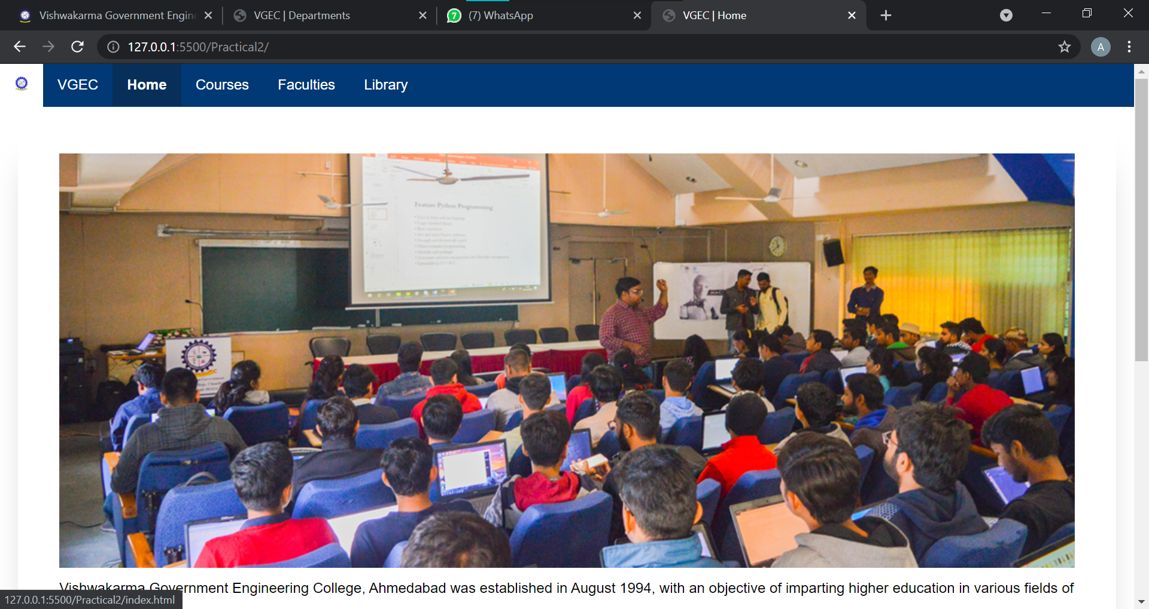

**Courses.html**

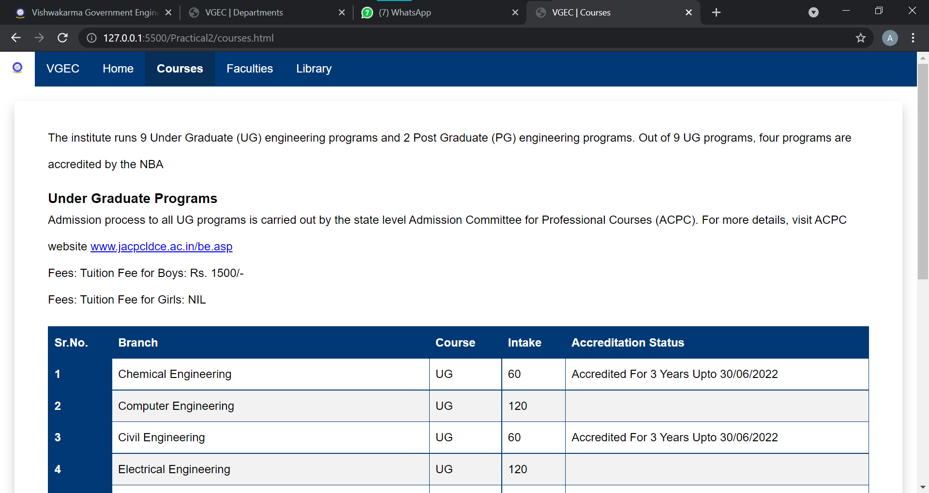

**Faculties.html**

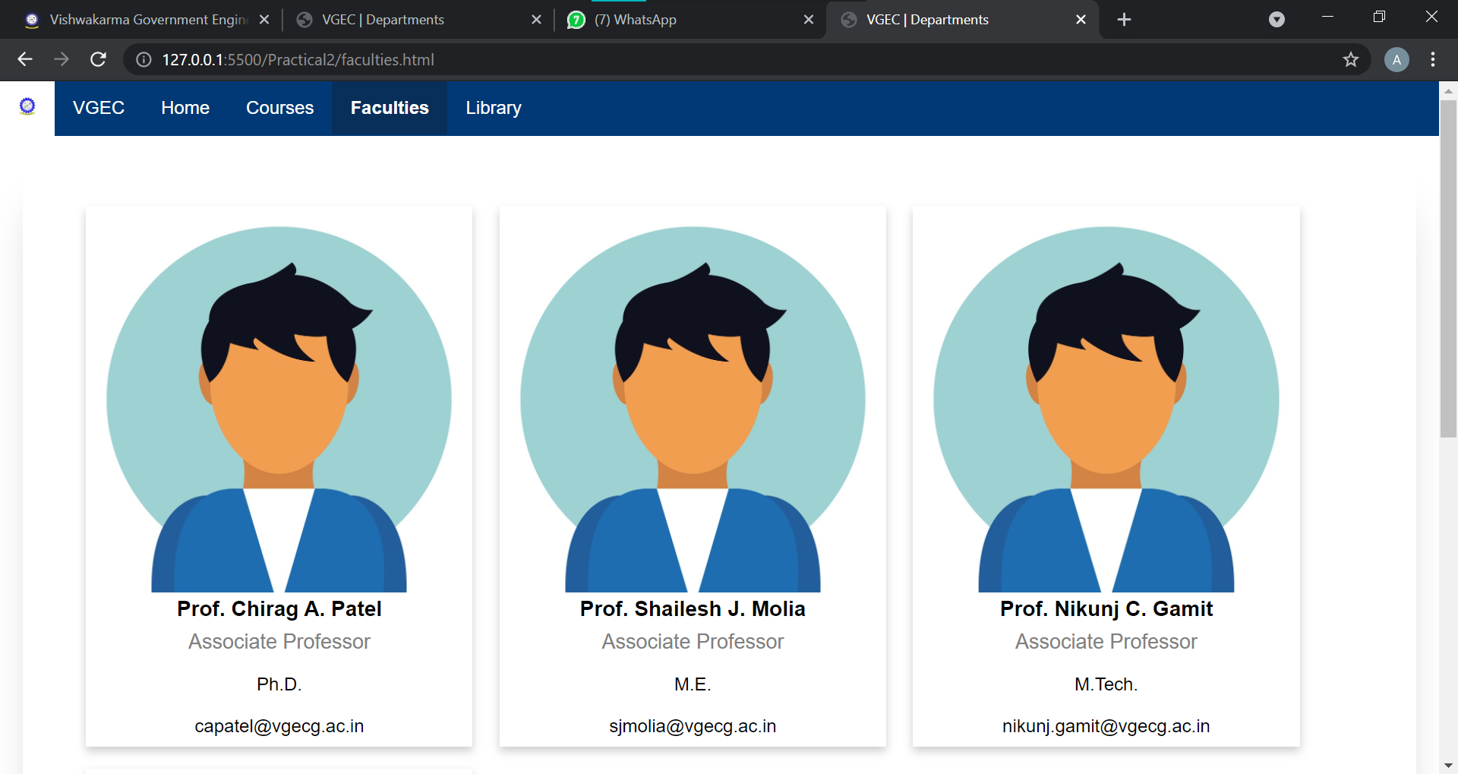

**Library.html**

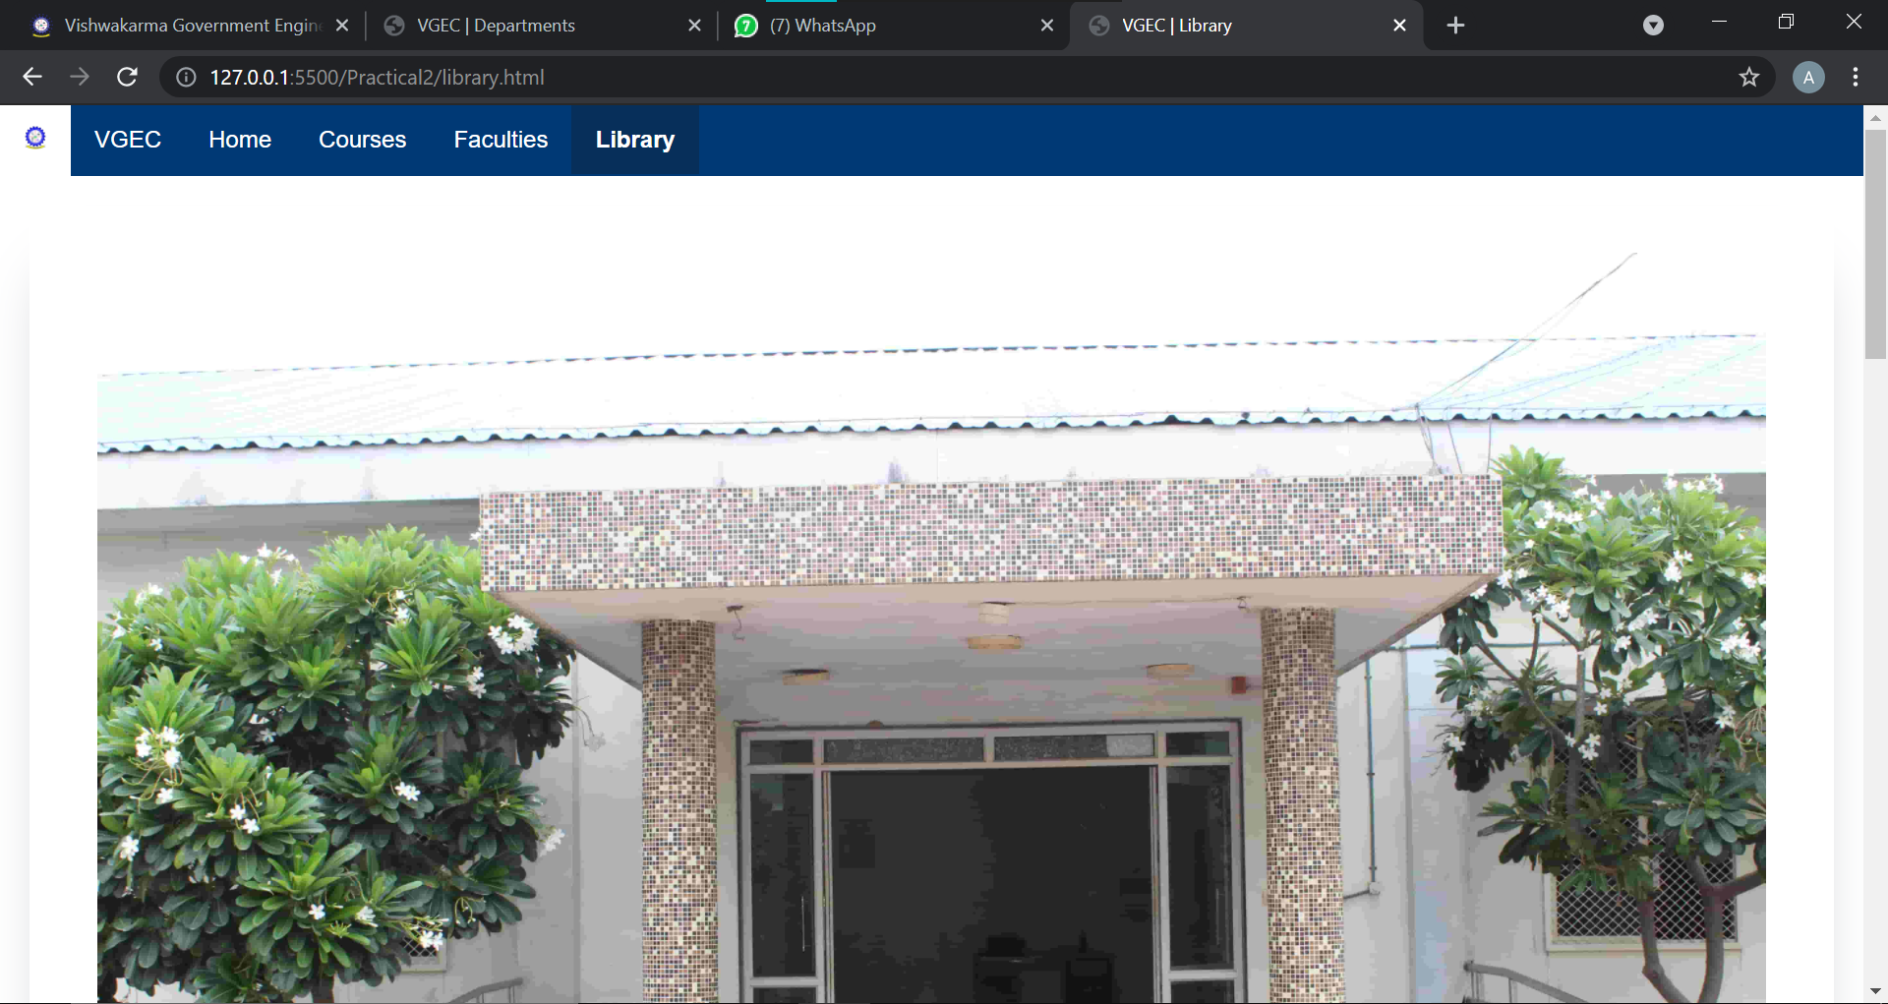

Practical 3

**Aim:**

Create your class timetable using table tag.

**Code:**

**Index.html**

<!DOCTYPE html>

<html lang="en">

  <head>

    <meta charset="UTF-8" />

    <meta http-equiv="X-UA-Compatible" content="IE=edge" />

    <meta name="viewport" content="width=device-width, initial-scale=1.0" />

    <title>IT - Sem 5 | Time Table</title>

  </head>

  <body>

    <div>

      <center>

        <b>

          VISHWAKARMA GOVERNMENT ENGG COLLEGE, CHANDKHEDA<br />

          INFORMATION TECHNOLOGY DEPARTMENT<br />

          Semester:V<br />

          ODD TERM 2021<br />

          WEF:- 07/06/2021

        </b>

      </center>

    </div>

    <br />

    <div>

      <center>

        <table align="center" border="1px" width="100%">

          <thead>

            <tr>

              <th>Day</th>

              <th>10:30 TO 12:30</th>

              <th>1:00 TO 2:00</th>

              <th>2:00 TO 3:00</th>

              <th>3:15 TO 4:15</th>

              <th>4:15 TO 5:15</th>

              <th>5:15 TO 6:15</th>

            </tr>

          </thead>

          <tbody>

            <tr>

              <td></td>

              <td></td>

              <td></td>

              <td colspan="2">B201</td>

              <td colspan="2">B201</td>

            </tr>

            <tr>

              <td>Monday</td>

              <td>

                B1 - ADA (DCP) B206A<br />

                B3 - WD (CAP) B203B <br />

                B4 - CN (CGC) B206B

              </td>

              <td>ADA (DCP)</td>

              <td>CN (JHV)</td>

              <td>

                OOAD (NST)<br />

                WD (CAP) B103

              </td>

              <td>PE (DJV)</td>

              <td>

                B1 - DE - 2A (VDP)<br />

                B2 - DE - 2A (CAP)<br />

                B3 - DE - 2A (JRD)<br />

                B4 - DE - 2A (DCP)<br />

                B104

              </td>

            </tr>

            <tr>

              <td>Tuesday</td>

              <td>

                B1 - OOAD (NST) B203A<br />

                B2 - CN (CGC) B206B<br />

                B3 - ADA (DCP) B206A<br />

                B4 - WD (CAP) B203B

              </td>

              <td>ADA (DCP)</td>

              <td>CN (CGC)</td>

              <td>PE (DJV)</td>

              <td>ADA (VDP)</td>

              <td>

                B1 - DE - 2A (NST)<br />

                B2 - DE - 2A (CGC)<br />

                B3 - DE - 2A (JHV)<br />

                B4 - DE - 2A (DCP)<br />B104

              </td>

            </tr>

            <tr>

              <td>Wednesday</td>

              <td>

                B2 - ADA (DCP) B206A<br />

                B3 - CN (CGC) B206B

              </td>

              <td>ADA (DCP)</td>

              <td>CN (CGC)</td>

              <td>PE (DJV)</td>

              <td></td>

              <td></td>

            </tr>

            <tr>

              <td>Thursday</td>

              <td></td>

              <td></td>

              <td>

                IE-CS (JHV)<br />

                DS (SJM) B103

              </td>

              <td>CN (CGC)</td>

              <td>

                IE-CS (JHV)<br />

                DS (SJM) B103

              </td>

              <td></td>

            </tr>

            <tr>

              <td>Friday</td>

              <td>

                B1 - CN (JHV) B206B<br />

                B2 - WD (CAP) B203B<br />

                B4 - ADA (DCP) B206A

              </td>

              <td>IPDC (JRD)</td>

              <td>IPDC (JRD)</td>

              <td>

                OOAD (NST)<br />

                WD (CAP) B103

              </td>

              <td>

                OOAD (NST)<br />

                WD (CAP) B103

              </td>

              <td></td>

            </tr>

            <tr>

              <td>Saturday</td>

              <td colspan="2">

                10:00 TO 2:00 &nbsp B1-CS(JHV) &nbsp B3-DS(SJM) &nbsp B4-DS(NST)

              </td>

              <td colspan="4">2:00 TO 6:00 &nbsp B2-CS(JHV)</td>

            </tr>

          </tbody>

        </table>

        <br />

        <table align="center" border="1px" width="100%">

          <thead>

            <tr bgcolor="yellow">

              <th colspan="2">SUBJECT DETAILS</th>

              <th colspan="2">FACULTY DETAILS</th>

              <th colspan="2">FACULTY DETAILS</th>

            </tr>

          </thead>

          <tbody>

            <tr>

              <td>3150703</td>

              <td>Alalysis and Design of Algorithms (ADA)</td>

              <td>VDP</td>

              <td>Prof V D Patel</td>

              <td>NCG</td>

              <td>Prof N C Gamit</td>

            </tr>

            <tr>

              <td>3151604</td>

              <td>Object Oriented Analysis and Design (OOAD)</td>

              <td>CAP</td>

              <td>Prof C A Patel</td>

              <td>JRD</td>

              <td>Prof J R Dave</td>

            </tr>

            <tr>

              <td>3150005</td>

              <td>Integrated Personality Development Course (IPDC)</td>

              <td>SJM</td>

              <td>Prof S J Molia</td>

              <td>NST</td>

              <td>Prof N S Trivedi</td>

            </tr>

            <tr>

              <td>3150709</td>

              <td>Professional Ethics (PE)</td>

              <td>CGC</td>

              <td>Prof C G Chand</td>

              <td>DCP</td>

              <td>Prof D C Patel</td>

            </tr>

            <tr>

              <td>3150001</td>

              <td>Design Engineering - II A (DE2A)</td>

              <td>DJV</td>

              <td>Prof D J Varia</td>

              <td>JHV</td>

              <td>Prof J H Vania</td>

            </tr>

            <tr>

              <td>3150714</td>

              <td>Institute Elective - Cyber Security (CS)</td>

            </tr>

            <tr>

              <td>3150710</td>

              <td>Computer Networks (CN)</td>

            </tr>

            <tr>

              <td>3151606</td>

              <td>Web Developmennt (Professional Elective Course 1) (WD)</td>

            </tr>

            <tr>

              <td>3151608</td>

              <td>Institute Elective - Data Science (DS)</td>

            </tr>

          </tbody>

        </table>

      </center>

    </div>

  </body>

</html>

**Screenshot:**

